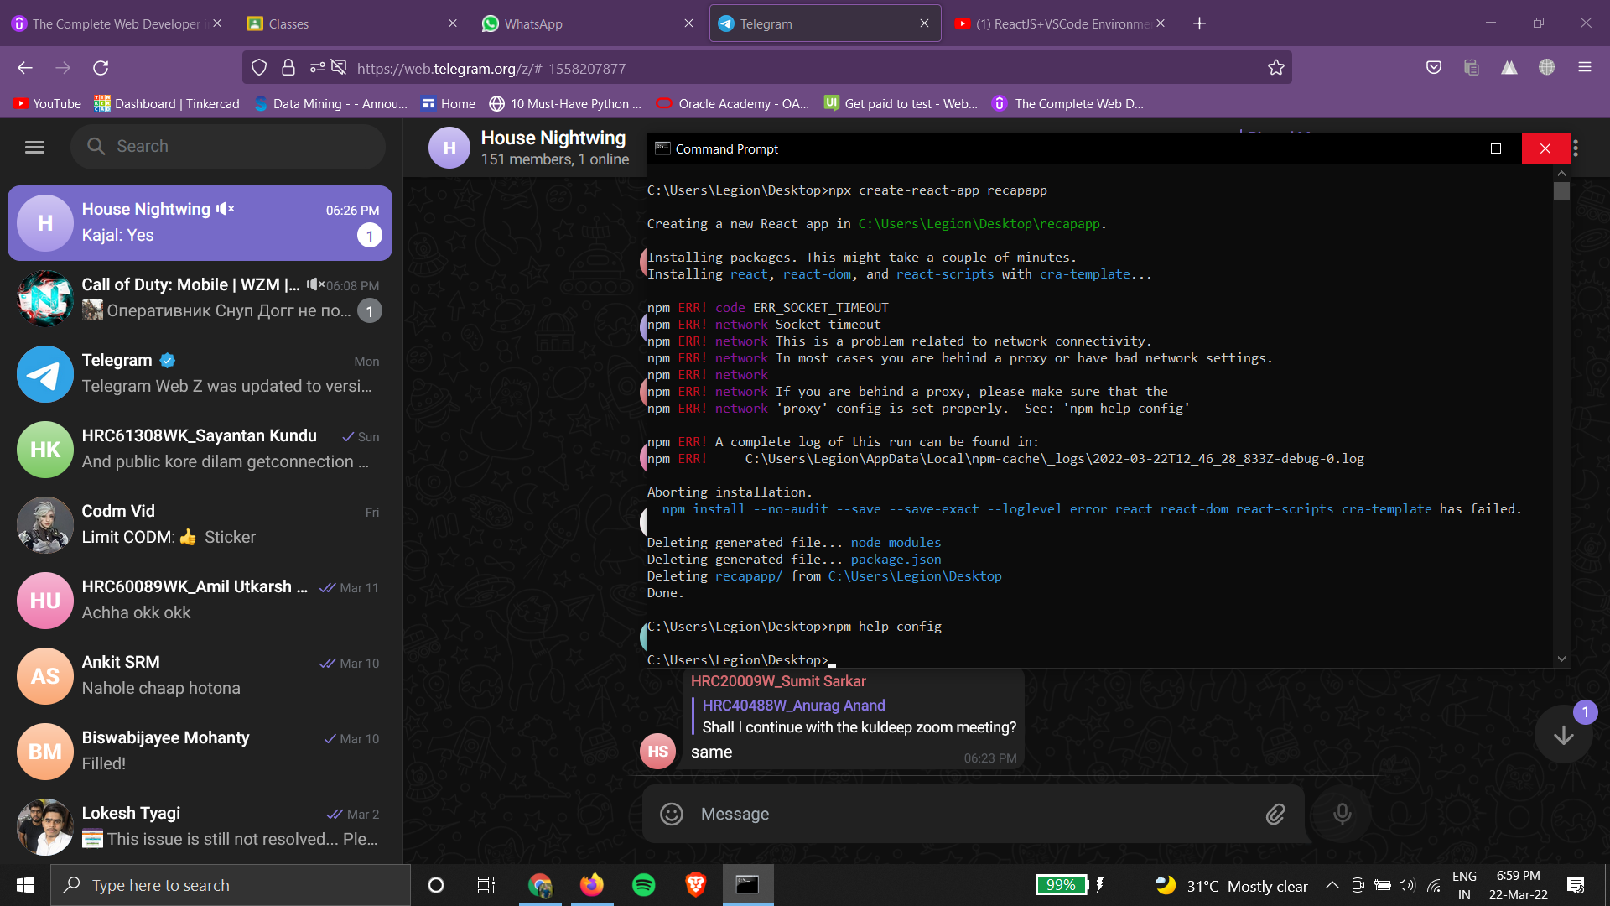

pagination

rowsPerPageOptions={[5, 10, 20]}

VISHNU SATWIK.K, [30-03-2022 18:18]  
These are approximate color   
codes- #283a46, #97a1a9, #2A3E4C, #14AFF

sx={{ border: 0, "& .MuiDataGrid-cellCheckbox": { color: "white" }, "& .MuiDataGrid-checkboxInput": { color: "white" }, "& .MuiDataGrid-columnHeaderTitle": { whiteSpace: "break-spaces", lineHeight: 1, }, "& .MuiTablePagination-root": { color: "white" }, color: 'white' }}

**package** com.devlin.prac;

**public** **class** Actor {

**private** **int** sl_no;

**private** String business_code;

**private** **int** cust_number;

**private** String clear_date;

**private** String business_year;

**private** String doc_id;

**private** String posting_date;

**private** String document_create_date;

**private** String document_create_date1;

**private** String due_in_date;

**private** String invoice_currency;

**private** String document_type;

**private** **int** posting_id;

**private** String area_business;

**private** **double** total_open_amount;

**private** String baseline_create_date;

**private** String cust_payment_terms;

**private** **int** invoice_id;

**private** **int** isOpen;

**private** String aging_bucket;

**private** String is_deleted;

**public** **int** getSl_no() {

**return** sl_no;

}

**public** **void** setSl_no(**int** sl_no) {

**this**.sl_no = sl_no;

}

**public** String getBusiness_code() {

**return** business_code;

}

**public** **void** setBusiness_code(String business_code) {

**this**.business_code = business_code;

}

**public** **int** getCust_number() {

**return** cust_number;

}

**public** **void** setCust_number(**int** cust_number) {

**this**.cust_number = cust_number;

}

**public** String getClear_date() {

**return** clear_date;

}

**public** **void** setClear_date(String clear_date) {

**this**.clear_date = clear_date;

}

**public** String getBusiness_year() {

**return** business_year;

}

**public** **void** setBusiness_year(String business_year) {

**this**.business_year = business_year;

}

**public** String getDoc_id() {

**return** doc_id;

}

**public** **void** setDoc_id(String doc_id) {

**this**.doc_id = doc_id;

}

**public** String getPosting_date() {

**return** posting_date;

}

**public** **void** setPosting_date(String posting_date) {

**this**.posting_date = posting_date;

}

**public** String getDocument_create_date() {

**return** document_create_date;

}

**public** **void** setDocument_create_date(String document_create_date) {

**this**.document_create_date = document_create_date;

}

**public** String getDocument_create_date1() {

**return** document_create_date1;

}

**public** **void** setDocument_create_date1(String document_create_date1) {

**this**.document_create_date1 = document_create_date1;

}

**public** String getDue_in_date() {

**return** due_in_date;

}

**public** **void** setDue_in_date(String due_in_date) {

**this**.due_in_date = due_in_date;

}

**public** String getInvoice_currency() {

**return** invoice_currency;

}

**public** **void** setInvoice_currency(String invoice_currency) {

**this**.invoice_currency = invoice_currency;

}

**public** String getDocument_type() {

**return** document_type;

}

**public** **void** setDocument_type(String document_type) {

**this**.document_type = document_type;

}

**public** **int** getPosting_id() {

**return** posting_id;

}

**public** **void** setPosting_id(**int** posting_id) {

**this**.posting_id = posting_id;

}

**public** String getArea_business() {

**return** area_business;

}

**public** **void** setArea_business(String area_business) {

**this**.area_business = area_business;

}

**public** **double** getTotal_open_amount() {

**return** total_open_amount;

}

**public** **void** setTotal_open_amount(**double** total_open_amount) {

**this**.total_open_amount = total_open_amount;

}

**public** String getBaseline_create_date() {

**return** baseline_create_date;

}

**public** **void** setBaseline_create_date(String baseline_create_date) {

**this**.baseline_create_date = baseline_create_date;

}

**public** String getCust_payment_terms() {

**return** cust_payment_terms;

}

**public** **void** setCust_payment_terms(String cust_payment_terms) {

**this**.cust_payment_terms = cust_payment_terms;

}

**public** **int** getInvoice_id() {

**return** invoice_id;

}

**public** **void** setInvoice_id(**int** invoice_id) {

**this**.invoice_id = invoice_id;

}

**public** **int** getIsOpen() {

**return** isOpen;

}

**public** **void** setIsOpen(**int** isOpen) {

**this**.isOpen = isOpen;

}

**public** String getAging_bucket() {

**return** aging_bucket;

}

**public** **void** setAging_bucket(String aging_bucket) {

**this**.aging_bucket = aging_bucket;

}

**public** String getIs_deleted() {

**return** is_deleted;

}

**public** **void** setIs_deleted(String is_deleted) {

**this**.is_deleted = is_deleted;

}

**public** Actor(**int** sl_no, String business_code, **int** cust_number, String clear_date, String business_year,

String doc_id, String posting_date, String document_create_date, String document_create_date1,

String due_in_date, String invoice_currency, String document_type, **int** posting_id, String area_business,

**double** total_open_amount, String baseline_create_date, String cust_payment_terms, **int** invoice_id,

**int** isOpen, String aging_bucket, String is_deleted) {

**super**();

**this**.sl_no = sl_no;

**this**.business_code = business_code;

**this**.cust_number = cust_number;

**this**.clear_date = clear_date;

**this**.business_year = business_year;

**this**.doc_id = doc_id;

**this**.posting_date = posting_date;

**this**.document_create_date = document_create_date;

**this**.document_create_date1 = document_create_date1;

**this**.due_in_date = due_in_date;

**this**.invoice_currency = invoice_currency;

**this**.document_type = document_type;

**this**.posting_id = posting_id;

**this**.area_business = area_business;

**this**.total_open_amount = total_open_amount;

**this**.baseline_create_date = baseline_create_date;

**this**.cust_payment_terms = cust_payment_terms;

**this**.invoice_id = invoice_id;

**this**.isOpen = isOpen;

**this**.aging_bucket = aging_bucket;

**this**.is_deleted = is_deleted;

}

}

package com.devlin.prac;

import java.io.IOException;

import java.sql.Connection;

import java.sql.DriverManager;

import java.sql.PreparedStatement;

import java.sql.ResultSet;

import java.util.ArrayList;

import java.util.HashMap;

import javax.servlet.ServletException;

import javax.servlet.annotation.WebServlet;

import javax.servlet.http.HttpServlet;

import javax.servlet.http.HttpServletRequest;

import javax.servlet.http.HttpServletResponse;

import com.google.gson.Gson;

/**

* Servlet implementation class DataLoading

*/

@WebServlet("/DataLoading")

public class DataLoading extends HttpServlet {

private static final long serialVersionUID = 1L;

/**

* Default constructor.

*/

public DataLoading() {

// TODO Auto-generated constructor stub

}

/**

* @see HttpServlet#doGet(HttpServletRequest request, HttpServletResponse response)

*/

protected void doGet(HttpServletRequest request, HttpServletResponse response) throws ServletException, IOException {

// TODO Auto-generated method stub

HashMap<Object, Object> Response = new HashMap<Object, Object>();

ArrayList<Actor> Actors = new ArrayList<Actor>();

try {

Class.forName("com.mysql.cj.jdbc.Driver");

Connection con = DriverManager.getConnection("jdbc:mysql://localhost:3306/grey_goose","root","root");

PreparedStatement ps = con.prepareStatement("select * from winter_internship");

//ps.setInt(1, 5);

ResultSet rs = ps.executeQuery();

while(rs.next()) {

Actor actor = new Actor(rs.getInt("sl_no"),

rs.getString("business_code"),

rs.getInt("cust_number"),

rs.getString("clear_date"),

rs.getString("business_year"),

rs.getString("doc_id"),

rs.getString("posting_date"),

rs.getString("document_create_date"),

rs.getString("document_create_date1"),

rs.getString("due_in_date"),

rs.getString("invoice_currency"),

rs.getString("document_type"),

rs.getInt("posting_id"),

rs.getString("area_business"),

rs.getDouble("total_open_amount"),

rs.getString("baseline_create_date"),

rs.getString("cust_payment_terms"),

rs.getInt("invoice_id"),

rs.getInt("isOpen"),

rs.getString("aging_bucket"),

rs.getString("is_deleted")

);

Actors.add(actor);

}

Response.put("actors", Actors);

}catch(Exception e) {

e.printStackTrace();

}

Gson gson = new Gson();

String jsonResponse = gson.toJson(Response);

response.setHeader("Access-Control-Allow-Origin", "*");

response.getWriter().append(jsonResponse);

}

/**

* @see HttpServlet#doPost(HttpServletRequest request, HttpServletResponse response)

*/

protected void doPost(HttpServletRequest request, HttpServletResponse response) throws ServletException, IOException {

// TODO Auto-generated method stub

doGet(request, response);

}

}